The Optimal Price: Methods, Challenges, and Outcomes of Stochastic Optimization of Product Prices
Asif Mohhamadi, Mason Riffee, Jacob Stallard, Aaron Witzel
The objective of this lab was to identify the price that maximizes revenue per customer. This objective was complicated by several sources of uncertainty. First, the number of customers visiting the store varies randomly from day to day, and a busy day does not necessarily produce more sales than a quiet one. As a result, an observed increase or decrease in revenue could not be attributed to a change in price alone, since many other factors could have produced it. Second, any estimate drawn from a sample carries statistical uncertainty: promising results from a small group of customers do not establish that the optimal price has been found, and repeating the same test on a different group would likely produce different results. Larger samples yield more precise estimates, but they come at a cost. Testing an inferior price for an extended period would give us high confidence in the result while sacrificing substantial revenue in the process. Finally, the revenue curve may contain several “good” prices but only one “best” price, which creates a risk of settling on a local maximum or spending too many customers near one before locating the global maximum. Our task was therefore threefold: to learn the best price, to test as few customers as possible in doing so, and to earn as much revenue as possible while learning.
Revenue measurements in our design were inherently noisy because both the number of customers visiting each day and each customer’s decision to purchase were random. To manage this noise, we compared prices using revenue per visiting customer rather than total daily revenue, so that a slow day would not be mistaken for a poor price. We also chose sample sizes strategically: approximately 300 customers per price in the grid search and approximately 200 customers per arm in each slope test. These sample sizes were large enough to keep standard errors small, but not so large that they substantially reduced average revenue by exposing excess customers to sub-optimal prices. In the grid search, $25 produced the highest mean revenue per customer (11.473), with a standard error of 0.73.
In our design, we never assume that an observed change in revenue is a real change. Our approach was to treat every comparison between prices as a statistical test, and at each step of gradient ascent, we sampled two separate, independent groups of customers. In these samples, we took one price at 1 dollar below the current price and the other price at 1 dollar above it. Once we had our prices, we ran a two-sample Z-test on the difference in their mean revenue per customer and divided that difference by the 2-dollar gap between the prices to give an estimate of the slope of the revenue curve. The sign of the slope told us whether raising or lowering the price was likely to increase revenue, and the standard error and 90% confidence interval told us how certain that estimate was. We used 90% confidence rather than 95% or 99% because higher confidence would have required testing more customers at prices that were likely not optimal, which would cost us revenue. We also did not require a result to be statistically significant before changing the price, because near the peak the differences in revenue are very small, so getting significant results would have required very large samples. Instead, each step moved the price in proportion to the estimated slope, so a weak or noisy estimate produced only a small adjustment. Our method had two safeguards that kept noise from sending the price off course: each move was capped at plus or minus 2 dollars, and the step size shrank over time (2/√t), so once we were close to the peak, random noise could not push the price far away. Finally, we were careful about how we read intervals that contained zero. After about the fifth iteration, most of the slope intervals included zero, and the price settled between roughly 27.50 and 28 dollars, which we took to be the flat top of the revenue curve. We did realize that it could also mean our samples were too small to detect the very small revenue differences near a peak, but we concluded that we were close to the optimum, not that we had proven 27.74 dollars was exactly optimal.
Our pricing experiments faced two interrelated challenges: how to distinguish the global maximum from local maxima, and how to minimize the cost of our experiment while maintaining sufficient power. We addressed the challenge of distinguishing maxima and the challenge of experiment cost, by dividing our experiment into two searches. Each search differed in its method and its specificity of prices.
Because our revenue “curve” was unknown, it was necessary to test the entire range of prices during our first search. Importantly, the experimental costs (in terms of lost revenue) of such a search could be extremely high if many customers were offered a grossly sub-optimal price. We therefore established a rough grid of pricing intervals ($10 to $60 at $5 intervals) to offer to customers. Using the wide $5 price increment allowed us to reduce experimental costs on two fronts: first, fewer experiments would need to be run to cover the range of possible prices, and second, fewer customers would be needed to sufficiently power a two-sample z-test if the pricing intervals were wide. For each price, we therefore offered roughly 300 customers the opportunity to purchase the product. This provided us with sufficient power to distinguish between the revenue effects of $5 price increments, while also minimizing the number of customers who were offered sub-optimal prices during the initial search. The results of our initial search are illustrated below: the mean observed revenue per customer at each price is shown with a 90% confidence interval. This approach allowed for a rough visual estimation of our revenue as a function of price: importantly, we can see that there is a revenue peak around $25, and a peak at $50. As the $25 peak exhibited no overlap in error bars with other peaks, we investigated only the $25 peak in our next search. 3257 customers were used during this initial search.
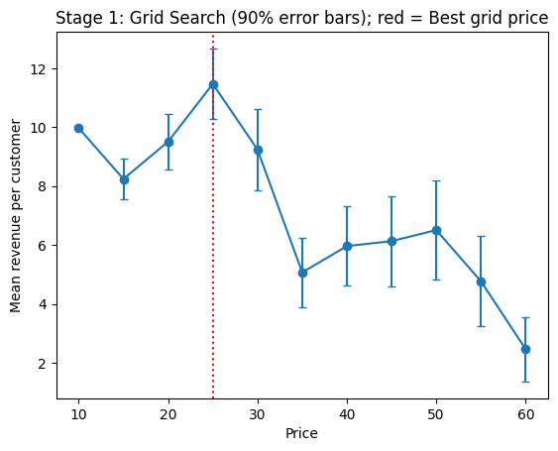
The natural course of action would be to “zoom in” on the $25 peak using a finer grid search, but here we were constrained by the cost of our experiments. A finer grid search would be too costly because a large, fixed number of fine grid intervals would be needed for this experiment, with each interval requiring a large number of customers (500 or greater) to participate. In other words, too many customers would be exposed to sub-optimal prices. In light of this challenge, we used gradient ascent to search for the maximum average per-customer revenue within the neighborhood of $25 prices. Because each “step” of the gradient ascent function is variable depending on the gradient, we thereby avoid the experimental costs of many fine grid pricing experiments. We used 20 iterations of gradient ascent; compared to a fine grid approach (i.e., evaluating a range of prices from $25 to $35 at $0.10 increments), we could run 80 fewer using gradient ascent than with a fixed grid. Assuming roughly 200 customers per experiment, this enabled us to offer 16,000 more customers the optimal product price following the end of our study, as compared to a second fixed grid search. We used a learning rate of 2, and we included roughly 200 customers per iteration of the gradient ascent study. The path is illustrated below: our final optimal price is $27.74. 7921 customers were used in this second search.

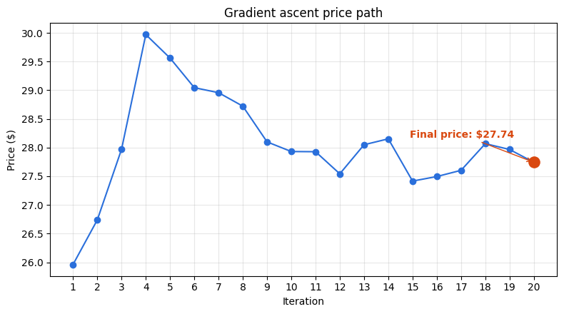
In conclusion, our two-stage design lets us find a near-optimal price without spending heavily on sub-optimal ones. The coarse grid search ruled out the $50 peak and identified the region around $25 as the global maximum, and gradient ascent then refined the price within that region, converging at $27.74 using far fewer customers than a fine grid would have required. In total we experimented on 11,178 customers: 3,257 in the grid search and 7,921 in the gradient ascent. Across the experiments we earned $114,976.89, an average of $10.286 per customer, which captured about 86.3% of the optimal revenue of $11.925 per customer. The shortfall reflects the cost of learning, since the grid stage deliberately offered some customers poor prices such as $10 and $60. In exchange, the chosen price of $27.74 is expected to capture essentially 100% of the optimal revenue per customer for all customers going forward. We handled noise by comparing revenue per customer, testing slopes with two-sample z-tests at 90% confidence, and damping each step so that random fluctuations could not push the price off course. The main tradeoff is between statistical power and cost: because revenue differences are tiny near the peak, we cannot prove that $27.74 is exactly optimal, but the added precision would not justify the revenue lost in obtaining it. We therefore recommend a price of about $27.74, with the understanding that any price in the flat region around it would perform nearly as well.

